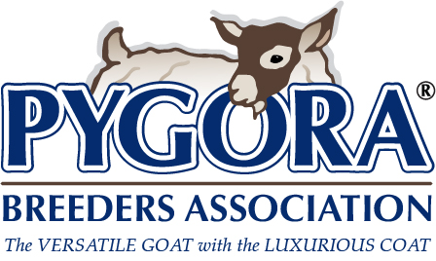
PBA Breeders Directory Request Form
The number of people requesting Pygora® information is growing by leaps and bounds. Many of these people are not only interested in Pygora goats, but they are looking for breeders in their area. The PBA Breeders Directory provides potential Pygora buyers with information about your animals and farm.
Active members in good standing can choose to be listed in the online PBA Breeders Directory. The fee to advertise in the PBA Breeders Directory is $15 per year for the first 75 words, and $15 for additional words up to 75.
After completing this form, you can either:
- Mail to the PBA Registrar, along with a payment by check.
- Email a digital copy of the completed form to the PBA Registrar (as a document file, clear and complete photo file, or scanned copy); choose payment by mailed check or PayPal invoice (Please note: a convenience fee will be added when using PayPal): select one Check ☐ PayPal ☐
PBA Membership Number: Click or tap here to enter text.
Your Name (s): Click or tap here to enter text.

Herd Name: Click or tap here to enter text.
Tattoo: Click or tap here to enter text.

Address: Click or tap here to enter text.
City: Click or tap here to enter text.

State: Click or tap here to enter text.
Zip: Click or tap here to enter text.

Phone(s): Click or tap here to enter text.
Fax: Click or tap here to enter text.

E-mail: Click or tap here to enter text.
Web Site: Click or tap here to enter text.

Check all descriptors that apply:
Breeding Stock (BR) ☐
Other Livestock (OL) ☐
Fleece (FL) ☐
Product Sales (PS) ☐
Fleece Processing (FLP) ☐
Promotional & Educational Materials (PR & ED) ☐
Stud Services (SS) ☐

Text for Breeders Directory Listing: Click or tap here to enter text.

Revised Sept 14, 2021

