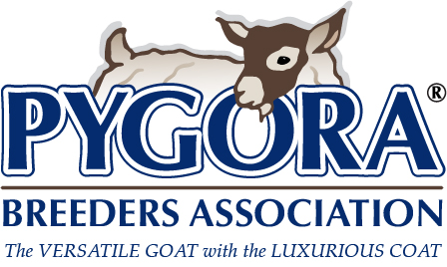
PBA Pre-Registration Application
This form is ONLY for pre-registration of goat kids, less than 1 year old.

Costs to register a goat are as follows:
Registration | Member Rate | Non-Member Rate
Doe | $7 | $14
Buck | $10 | $20
Wether | $5 | $10
Transfer of Ownership | $5 | $10
Replacement or Correction | $7 | $7
Rush Fees * (per goat) | $20 + postage | $20 + postage
* Rush is anything needed sooner than 4 weeks from post mark date.

Pre-registering kids requires an application, payment and a photo:
- Fill out a registration application for each individual kid.
- Send a full side view (with goat looking at the camera), out of fleece color photo to the PBA Registrar - taken before 3 weeks of age. These can be sent as a printed copy, or a good resolution digital photo file. For all random markings - provide as many photos as needed to show markings. Be sure to label photos so they can be matched to an individual kid.

After completing this form, you can either:
- Mail to the PBA Registrar, along with a payment by check. OR
- Email a digital copy of the completed form to the PBA Registrar (as a document file, clear and complete photo file, or scanned copy); choose payment by mailed check or PayPal invoice (Please note: a convenience fee will be added when using PayPal): select one Check ☐ PayPal ☐

*** IF THE PARENTS ARE NOT PERMANENTLY REGISTERED, THE KIDS CANNOT BE REGISTERED! ***
Please download/read the information from: Rules for Pygora Goat Registration; missing or incorrect data will delay your registration. If you have questions, please contact the contact the PBA Registrar. Required fields are noted with “*”. Fill in all applicable fields.

PBA Membership Number: * Click & Enter
Your Name (s): * Click & Enter
Address: * Click & Enter
City: * Click & Enter
State: * Click & Enter Zip: * Click & Enter
Phone(s): Click & Enter E-mail: Click & Enter
Out-of-fleece color: * as per list: Choose color (Refer to the PBA Color Chart for descriptions if needed)
Sex: * Click & Select Birthdate: * Select Date
Name of Pygora, with Herdname : * Click & Enter
Number of Kids in Birth: * Male: # of males Female: # of females
Tattoo Location: * Click & Select
Tattoo Used * Right (farm ID): Click & Enter Left (year-kid number): Click & Enter
Microchip Number: * (if used) Click & Enter Microchip Location: * (if used) Click & Select
Disbudded: * Click & Select
Random Markings: (enter as needed; ie socks, belly bands, spots, saddles, etc.) Click & Enter

***If you were not the Sire's owner or the Dam’s owner at time of conception, please refer information found in the Rules for Pygora Goat Registration, and include additional forms as needed.***
Sire's Registration #: * Click & Enter Name of Sire: * Click & Enter
Dam's Registration #: * Click & Enter Name of Dam: * Click & Enter

***This Next Section Only Needed for Ownership Transfer, if Concurrent with Pre-Registration***
A transfer of ownership will cost an additional $5 for members and $10 for non-members.
NEW OWNER INFO:
New Owner's Name: Click & Enter
Date Transferred: Select date
New Owner's PBA Member # (or NA): Click & Enter
New Owner's Address: Click & Enter
New Owner's City: Click & Enter
New Owner's State: Click & Enter New Owner's Zip Code: Click & Enter
New Owner's Phone: Click & Enter New Owner's Email Address: Click & Enter

Check here if you need a replacement certificate: ☐
Check here to send the pre-registration certificate directly to the new owner. ☐
Check here if this is a RUSH request: ☐

